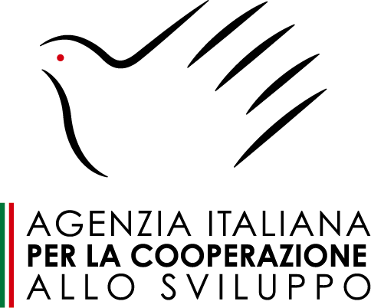
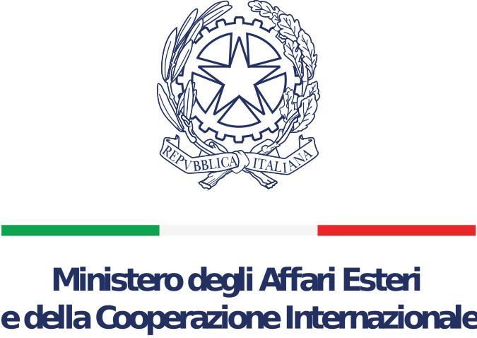
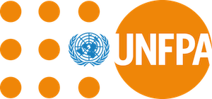

PRESS RELEASE

The United Nations Population Fund joins forces with Italian cooperation to reduce maternal and child mortality in the Central African Republic.

Bangui, December 11, 2023. The United Nations Population Fund (UNFPA) signs today a partnership agreement with the Italian Cooperation to meet maternal and neonatal health needs in the Central African Republic (CAR). This important event witnessed by the Government of Central African Republic and the UNFPA Resident Representative Dr Shible Sahbani, the Italian Ambassador H.E. Filippo Scammacca, the head of the AICS regional office in Khartoum Dr Michele Morana and the director of the Bangui Pediatric Complex, Professor Jean Chrysostome Gody, also marks the effective start of activities linked to its implementation for the benefit of Central African communities.

Over the next three years, UNFPA will continue its contribution to the reduction of maternal and neonatal mortality in the CAR thanks to financial support of five (05) million Euros mobilized from the Italian Cooperation. As stated by Dr Shible SAHBANI, this project aims “to strengthen the resilience of maternal and neonatal services in Bangui through improved capacity to provide effective health care to the mother-child couple within the Pediatric Hospital and University Complex of Bangui (CHUPB)”.

The program will provide quality maternal and neonatal care, infection prevention and control, awareness-raising on sexual and reproductive health as well as the rehabilitation of neonatal infrastructure within the complex. This project will benefit:
● 50 midwives, nurses and health personnel trained to care for the mother-child couple during the perinatal period and to neonatal emergencies;
● More than 4,300 newborns admitted to CHUPB each year;
● More than 1,500 mothers sensibilized on sexual and reproductive health and essential newborn care every year;
● 81 medical and paramedical professionals trained in reproductive and maternal-child health.

Also, the project will create and equip a safe space for women including survivors of Gender-Based Violence (GBV) and offer comprehensive GBV case management services.

The Bangui Pediatric Complex, the only national tertiary-level reference hospital for pediatric care with a capacity of 270 beds, is facing overrun due to the dysfunction of peripheral health structures, leading to an increase in hospitalizations. Some services, such as those dedicated to nutritional care, accommodate three times more patients than their initial capacity allows. The project will provide CHUPB with the essential resources necessary for the immediate care of patients. Consequently, it will guarantee the supply of medicines, reagents, equipment and consumables necessary for the continued services within the hospital during the project implementation period.

Honored by his effective presence at the launch of the project, Dr Michele Morana, Regional Director of AICS office in Khartoum, stressed that “the project financed by Italy will strengthen the resilience of maternal and neonatal services in Bangui”. He added that this initiative aims to improve the capacity of health facilities, ensuring effective emergency response and empowerment of mothers, with a focus on nutrition, maternal and child health.

UNFPA will work with the NGO Doctors with Africa (CUAMM) for the implementation of this project given its long experience in the field of maternal and neonatal health care, in collaboration with the Ministry of Health as well as UNFPA technical staff who will ensure overall supervision of the implementation of the project and coordination for the achievement of the expected results. To ensure quality implementation of the project, UNFPA will adopt an in-situ result-oriented project management and monitoring approach.

The Italian Government regularly supports the health sector in CAR, with the aim to strengthen the national health system, improve access to health care, train qualified personnel and provide specialized and quality care.

The Central African Republic (CAR) is a landlocked country marked by recurring political and humanitarian crises. As a result, the health system faces major challenges that limit the availability and accessibility of essential health services, particularly for mother and newborn, and generally for sexual and reproductive health. Maternal and neonatal mortality constitutes a major public health problem in CAR, with a maternal mortality ratio estimated at 835 deaths per 100,000 live births (UNFPA, 2022) and a neonatal mortality rate of 46 deaths per 1,000 live births (WHO 2015). This project will provide a response to the government's efforts to reduce maternal and neonatal mortality.

~~~~~~~
For more information, please contact :
· Theophane PATINVOH : patinvoh@unfpa.org, +236 72 30 05 25(Medias)

